## DATA STRUCTURE ASSIGNMENT NUMBER – 02

**Aim:** Accept conventional matrix and convert it into Sparse matrix. Implement Simple Transpose and Fast Transpose Algorithm on Sparse Matrix.

## PROGRAM CODE:

#include<stdio.h> void main()

{

int i,j,k,m,n,p,q,sum,count=0;

printf("\t\t\t\t\t\t WELCOME TO THE PROGRAM OF SPARSE MATRIX\n"); printf("Enter the Number of Rows and Columns of the Matrix\n"); scanf("%d %d",&m,&n);

int a[m][n],b[m][n],c[m][n];

printf("\nEnter the elements of the First Matrix:\n"); for ( i = 0; i <m; i++)

{

for ( j = 0; j < n; j++)

{

scanf("%d",&a[i][j]); if (a[i][j]==0)

{

count=count+1;

}

}

}

printf("\nThe First Matrix is:\n\n"); for ( i = 0; i <m; i++)

{

for ( j = 0; j < n; j++)

{

printf(" %d ",a[i][j]);

}

printf("\n");

}

if (count>((m*n)/2))

{

printf("\nNumber of Zeros is:%d\n",count);

printf("Number of elements other than Zeros are:%d\n",(m*n)-count); printf("As number of Zeros are more than remaining elements\n"); printf("\n\t\t\t\t\t\tTHE GIVEN MATRIX IS SPARSE MATRIX\n"); printf("\nThe 3 Tuple Representation of SPARSE Matrix is:\n"); printf("\nRows Columns Values");

for ( i = 0; i < m; i++)

{

for ( j = 0; j < n; j++)

{

if(a[i][j]!=0)

{

printf("\n %d %d %d",i,j,a[i][j]);

}

}

printf("\n");

}

}

else

{ printf("\nNumber of Zeros is:%d\n",count);

printf("Number of elements other than Zeros are:%d\n",(m*n)-count); printf("As number of Zeros are less than remaining elements\n"); printf("\n\t\t\t\t\t\tTHE GIVEN MATRIX IS DENSE MATRIX\n"); printf("\nThe 3 Tuple Representation of DENSE Matrix is:\n"); printf("\nRows Columns Values");

for ( i = 0; i < m; i++)

{

for ( j = 0; j < n; j++)

{

if(a[i][j]!=0)

{

printf("\n %d %d %d\n",i,j,a[i][j]);

}

}

printf("\n");

}

}

printf("Enter the Number of Rows and Columns of the Matrix\n"); scanf("%d %d",&p,&q);

//int a[p][q],b[p][q],c[p][q];

printf("\nEnter the elements of the Second Matrix:\n"); for ( i = 0; i <p; i++)

{

for ( j = 0; j < q; j++)

{

scanf("%d",&b[i][j]); if (b[i][j]==0)

{

count=count+1;

}

}

}

printf("\nThe Second Matrix is:\n\n"); for ( i = 0; i <p; i++)

{

for ( j = 0; j < q; j++)

{

printf(" %d ",b[i][j]);

}

printf("\n");

}

for ( i = 0; i <p; i++)

{

for ( j = 0; j < q; j++)

{

c[i][j]=a[i][j]+b[i][j];

}

}

if (m==p && n==q)

{ printf("\nTHE MATRIX IS SQUARE MATRIX \n"); printf("\nYOU CAN DO THE ADDITION OF TWO MATRICES\n"); printf("\nTHE SUM OF TWO MATRICES IS:\n");

for ( i = 0; i <m; i++)

{

for ( j = 0; j < n; j++)

{

printf(" %d ",c[i][j]);

}

printf("\n");

}

}

else

{

printf("\nYOU CANNOT DO THE ADDITION OF TWO MATRICES\n");

printf("\nAS THE MATRIX IS NOT SQUARE MATRIX\n");

}

if (n!=p)

{

printf("\nMULTIPLICATION OF TWO MATRICES IS NOT POSSIBLE\n");

}

else

{

for ( i = 0; i < m; i++)

{

for ( j = 0; j < q; j++)

{

sum=0;

for ( k = 0; k < m; k++)

{

sum=sum+(a[i][k]*b[k][j]);

}

c[i][j]=sum;

}

}

printf("\nMULTIPLICATION OF TWO MATRICES IS:\n");

for ( i = 0; i < m; i++)

{

for ( j = 0; j < q; j++)

{

printf(" %d\t",c[i][j]);

}

printf("\n");

}

}

}

## OUTPUT:

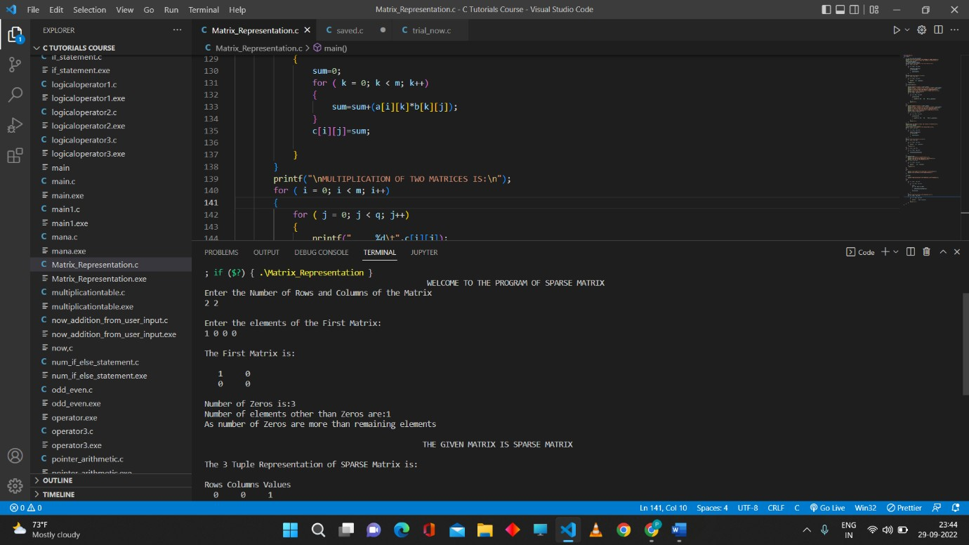

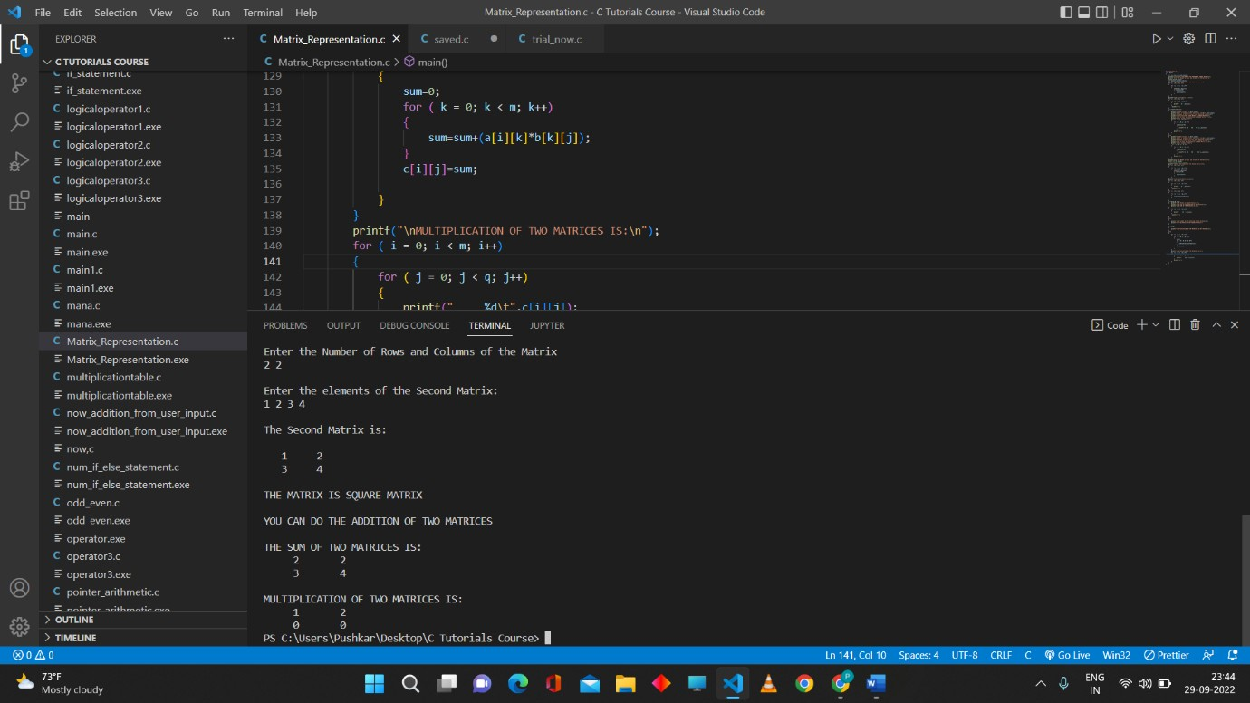

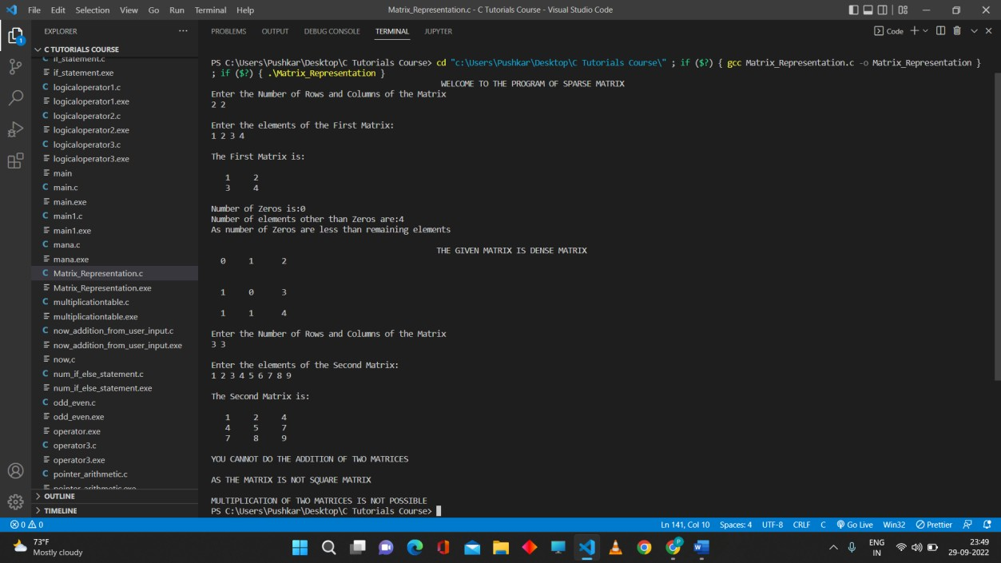

**Conclusion:** Thus, we have successfully executed the program for Sparse Matrix and also able to do the 3 Tuple Representation as well as Addition and Multiplication of the Two Matrices.